技術翻訳専門講座 ＩＴコース（和訳） サンプル課題

次の英文を和訳し、MS-Word形式ファイルで事務局答案係に提出してください。なお、図面内で翻訳が必要と思われる語は対訳形式で記載してください。

課題１
Computer
A computer is a programmable machine. The two principal characteristics of a computer are: It responds to a specific set of instructions in a well-defined manner and it can execute a prerecorded list of instructions (a program).
Modern Computers Defined
Modern computers are electronic and digital. The actual machinery — wires, transistors, and circuits — is called hardware; the instructions and data are called software.
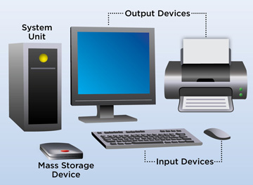
All general-purpose computers require the following hardware components:
Memory: enables a computer to store, at least temporarily, data and programs.
Mass storage device: allows a computer to permanently retain large amounts of data. Common mass storage devices include solid state drives (SSDs) or disk drives and tape drives.
Input device: usually a keyboard and mouse, the input device is the conduit through which data and instructions enter a computer.
Output device: a display screen, printer, or other device that lets you see what the computer has accomplished.
Central processing unit (CPU): the heart of the computer, this is the component that actually executes instructions.
In addition to these components, many others make it possible for the basic components to work together efficiently. For example, every computer requires a bus that transmits data from one part of the computer to another.
（出典元：http://www.webopedia.com/TERM/C/computer.html）

